

**Daffodil Institute Of IT**

**Department of Computer Science and Engineering (CSE)**

**6th semester**

**Project Report**

**Project Title** : Smoke/Gas Detector Using Arduino Uno

**Course Title** : Embedded System Programming Lab

**Course code**  : 530224

**Student Details :**

|  |  |  |
| --- | --- | --- |
| **Name** | **ID** | **Registration ID** |
| Md. Moinul Islam | 200024 | 19502004940 |
| Abdullah Al Maruf | 200014 | 19502004920 |
| Anas Bin Abbas | 200002 | 19502004918 |
| Md. Anwar hossain | 200110 | 19502004917 |

**Submitted To** : **Abdullah Al Azad**

Lecturer

Department of Computer Science and Engineering

Daffodil Institute of IT (DIIT)

Submission Date :

**Project Name: Smoke/Gas Detector Using Arduino Uno**

**1. Introduction**

The purpose of this project is to design and implement a smoke/gas detector using an Arduino Uno. The system aims to detect the presence of harmful gases and smoke in the environment and alert the user through visual and audible alarms. This project is useful in residential, commercial, and industrial settings to enhance safety by providing early warnings of potential fire hazards or gas leaks.

**2. Objectives**

* To design a smoke/gas detection system using Arduino Uno.
* To implement an alarm system that triggers upon detection of smoke or gas.
* To display the status of the environment on an LCD screen.
* To create a cost-effective and efficient safety device.

**3. Components**

**Hardware**

* Arduino Uno
* MQ-2 Gas Sensor
* Buzzer
* LED
* Resistors
* Breadboard
* Jumper Wires

**Software**

* Arduino IDE

**4. Circuit Diagram**

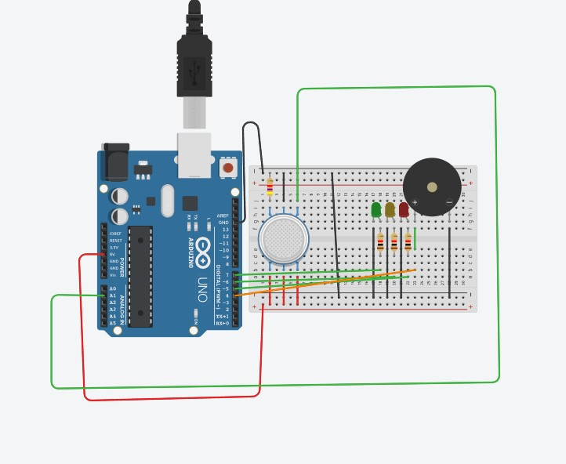

**5. Working Principle**

The MQ-2 sensor is capable of detecting various harmful gases like LPG, smoke, alcohol, propane, hydrogen, methane, and carbon monoxide. When the concentration of these gases exceeds a certain threshold, the sensor outputs a higher voltage which is read by the Arduino. The Arduino then processes this input and triggers the buzzer and LED to alert the user.

**6. Implementation**

**6.1 Connecting the Components**

1. **MQ-2 Gas Sensor**:
   * VCC to 5V on Arduino
   * GND to GND on Arduino
   * AO to A0 on Arduino
2. **Buzzer**:
   * Positive pin to digital pin 8 on Arduino
   * Negative pin to GND on Arduino
3. **LED**:
   * Anode to digital pin 7 on Arduino
   * Cathode to GND via a resistor

**6.2 Programming the Arduino**

int const PINO_SGAS = A1;

int LED_VERDE = 7;

int LED_AMARELO = 6;

int LED_VERMELHO1 = 5;

int LED_VERMELHO2 = 4;

void setup(){

pinMode(LED_VERDE, OUTPUT);

pinMode(LED_AMARELO, OUTPUT);

pinMode(LED_VERMELHO1, OUTPUT);

pinMode(LED_VERMELHO2, OUTPUT);

Serial.begin(9600);

}

void loop(){

int valor = analogRead(PINO_SGAS);

valor = map(valor, 300, 750, 0, 100);

digitalWrite(LED_VERDE, HIGH);

digitalWrite(LED_AMARELO, valor >= 30 ? HIGH : LOW);

digitalWrite(LED_VERMELHO1, valor >= 50 ? HIGH : LOW);

digitalWrite(LED_VERMELHO2, valor >= 80 ? HIGH : LOW);

delay(250);

}

**6.3 Testing the System**

* Upload the code to the Arduino Uno.
* Power up the system.
* Expose the MQ-2 sensor to smoke or gas to test if the alarm triggers and the LCD displays the correct status.

**7. Results**

The smoke/gas detector successfully detects harmful gases and smoke. When the concentration of gas exceeds the threshold, the buzzer sounds, the LED lights up, and the LCD displays a warning message. In the absence of harmful gases, the system remains in a safe state with no alarms triggered.

**8. Conclusion**

This project demonstrates a simple yet effective smoke/gas detection system using Arduino Uno. The system can be further enhanced by adding features such as wireless notifications, integration with home automation systems, and using more advanced gas sensors for specific gas detection.